**TEJAS MONPARA**

**DATABASE ASSIGNMENT**

Q-1 Print Distinct City from Table Customers and Print Count Distinct City from Table Customers.

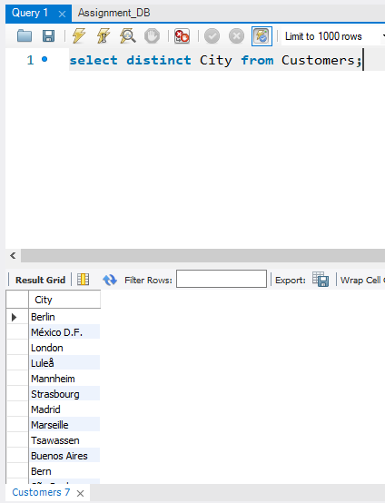

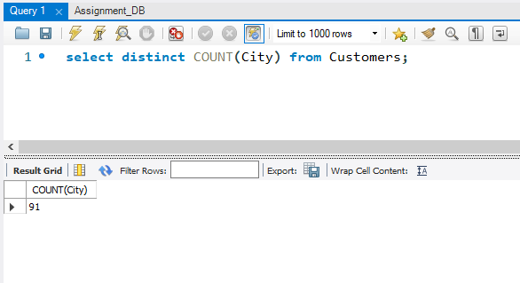

Q-2 Write a SQL query to get the least number of quantities and the highest number of quantities bought by the user consider the OrderDetails Table.

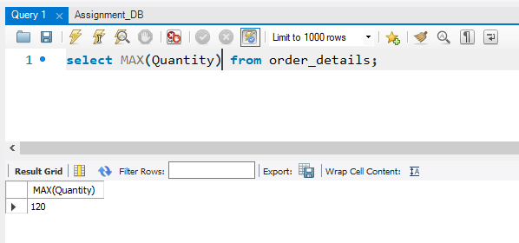

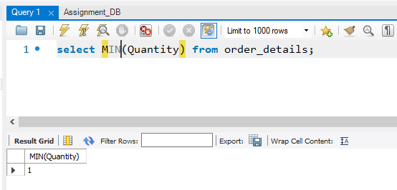

Q-3 Print the total and average number of quantities ordered by users, consider the OrderDetails Table.

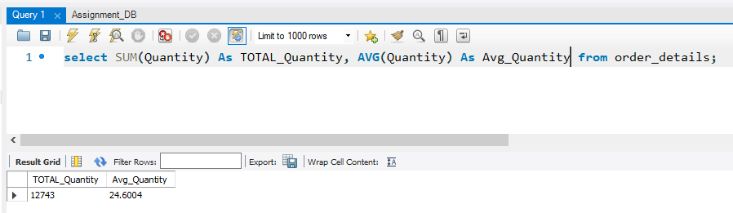

Q-4 Print name of the product which is present at the 5th position

till the 15th position from Products table, use LIMIT keyword.

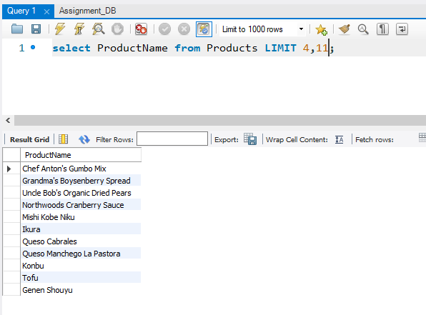

Q-5 Write a SQL query for all the details of the supplier whose name consists of “A” at the second position from the Suppliers table.

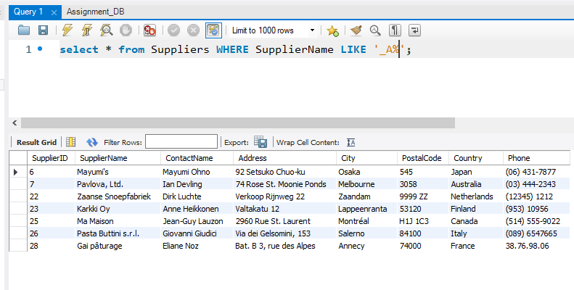Q-6 Print the details of the customer who doesn’t stay in the USA and Canada from the Customers table.

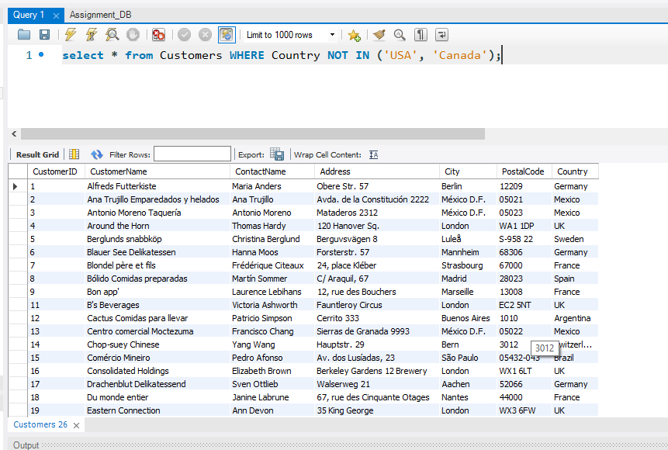

Q-7 Print the details of all the orders which were placed between the year 2020 to 2021 also print the same in descending order from the OrderDetails table.

* As there is no data between these years so it’s empty.

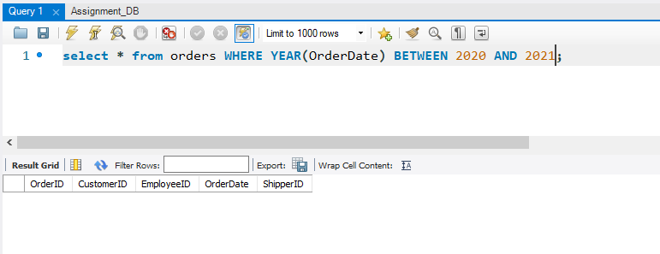

Q-8 Write a query to show the distinct city and their count from the Customers table.

DISTINCT CITY LIST

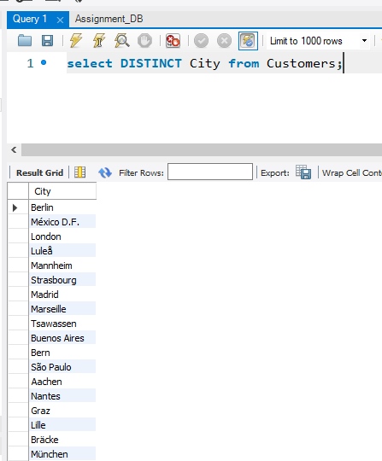

DISTINCT CITY COUNT

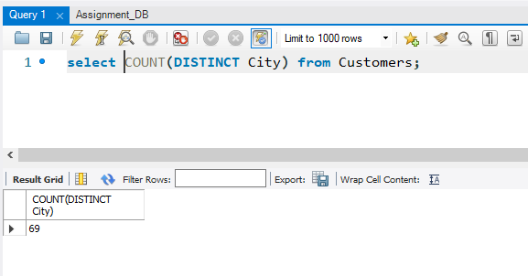

Q-9 Write a query to fetch details of all employees excluding the employees with first names, “Sanjay” and “Sonia” from the Employees table.

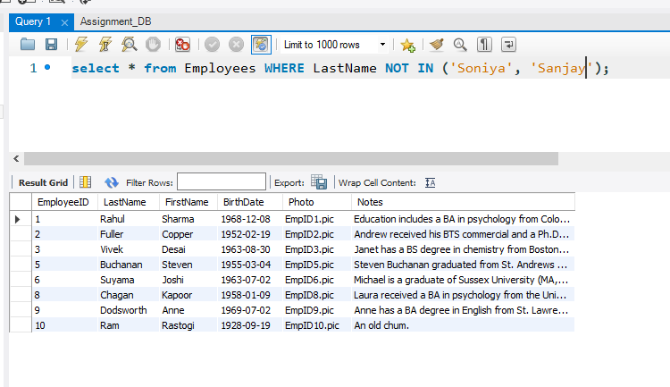

Q-10 Duplicate a table as similar to the Suppliers table and name it as SupplierDetail.

* Look 61th # to see the output

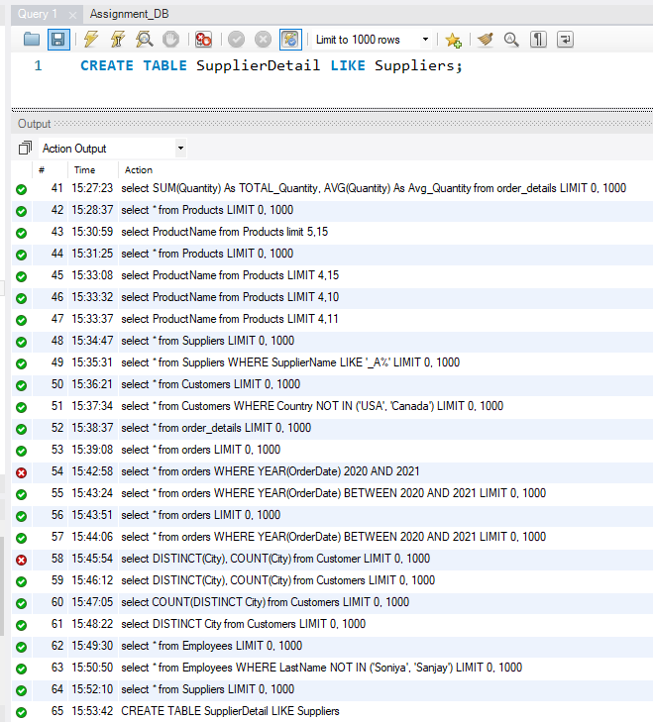

Q-11 Delete customer details whose country is Venezuela and print the rest of the Customer table

